Expt. No. : 16 VIRTUAL CLASSROOM MANAGEMENT

PO-PSO Mapping Table :
PO1 | PO2 | PO3 | PO4 | PO5 | PO6 | PO7 | PO8 | PO9 | PO10 | PO11 | PO12 | PSO1 | PSO2 | PSO3
3 | 2 | 3 | 2 | 2 | 1 | - | 3 | 1 | 2 | - | - | 3 | 2 | 1

PSO Justification :
PSO | Relevance | Justification
PSO1 – Apply fundamental computing knowledge | 3 | Uses Java fundamentals, distributed computing, and API principles to create a scalable system.
PSO2 – Design and implement solutions | 2 | Integrates design thinking and programming logic to create an efficient, connected system.
PSO3 – Use modern tools and technologies | 1 | Uses cloud-based and container tools to modernize traditional RMI applications.

PO Justification:

PO | Relevance | Justification
PO1 – Engineering Knowledge | 3 | Strongly applies computing fundamentals, Java RMI, networking, and distributed systems in practice.
PO2 – Problem Analysis | 2 | Involves identifying and resolving server–client communication, runtime, and configuration issues.
PO3 – Design/Development of  Solutions | 3 | Designs a complete client–server system integrating GUI, backend, and API services effectively.
PO | Relevance | Justification
PO4 – Conduct Investigations of  Complex Problems | 2 | Analyzes backend logic, request handling, and deployment behavior to ensure smooth execution.
PO5 – Modern Tool Usage | 2 | Employs modern technologies such as Spring Boot, Docker, and Render for deployment and hosting.
PO6 – The Engineer and Society | 1 | Considers the usefulness and accessibility of the calculator system for general public use.
PO8 – Ethics | 3 | Encourages following ethical coding standards, proper data handling, and secure communication protocols.
PO9 – Individual and Team  Work | 1 | Can be implemented individually or collaboratively, promoting teamwork and responsibility.
PO10 – Communication | 2 | Demonstrates technical communication through structured APIs, documentation, and code clarity.

Introduction :
Virtual Classroom Management refers to the deployment and supervision of educational activities within an online environment, allowing students and teachers to interact, learn, and collaborate remotely using internet-enabled tools. Unlike traditional classrooms, a virtual classroom is built to support real-time engagement through video conferencing, interactive whiteboards, chat features, polling, and digital resource sharing, making learning accessible to participants regardless of their physical location.​
This management involves establishing a structured, secure, and engaging platform for online courses, where instructors organize sessions, share instructional content, monitor attendance, assess students, and foster communication in a flexible manner. Core objectives include maximizing participation, ensuring discipline, tracking learner progress, and enabling collaboration through breakout groups and collaborative activities—all conducted in a digitally connected environment.​
Overall, virtual classroom management is crucial for modern education, as it provides the technological and strategic foundation required to transfer classroom dynamics into the digital age, improves accessibility, and supports personalized learning for diverse student groups.​

Project Distribution :
The Virtual Classroom Management System is designed to create a digital platform where teachers and students interact, collaborate, and conduct classroom activities remotely, overcoming the constraints of physical location and enabling seamless online education. The project focuses on building an intuitive, easy-to-use interface that facilitates core classroom actions such as scheduling classes, joining sessions, sharing resources, tracking attendance, and maintaining effective communication.​
The backend leverages a MySQL database to securely store information about scheduled classes, faculty details, session timings, and meeting links. The frontend uses Java Swing to provide graphical user controls for adding new classes, viewing existing schedules, and deleting classes as needed, all through a connected application. Users can manage class data, handle schedules, and update information dynamically through the UI, which directly interacts with the database for real-time results.​​
This project implements essential classroom management features, including:
- Registration of subjects and faculty members.
- Efficient scheduling with date, time, and meeting link fields.
- Live access and manipulation of class entries.
- Visual feedback for successful operations and errors.
By centralizing class information, the Virtual Classroom Management System streamlines the educational workflow, making it faster and easier for faculty to manage sessions while offering students timely access to all their scheduled online classes. The solution is scalable and can be extended with additional features such as resource sharing, assessments, and group activities for more comprehensive classroom experiences.

System Architecture :

Coding :
Frontend.java:

package com.classroomapp;

import javax.swing.*;
import java.awt.*;
import java.awt.event.*;
import java.sql.*;

public class VirtualClassroomManagement extends JFrame implements ActionListener {

JTextField txtSubject, txtFaculty, txtDate, txtTime, txtLink;
JButton btnAdd, btnView, btnDelete;
Connection con;

final String URL = "jdbc:mysql://localhost:3306/classroomdb";
final String USER = "root"; // change if needed
final String PASS = "Harini@2006"; // your MySQL password

public VirtualClassroomManagement() {
setTitle("Virtual Classroom Management");
setSize(500, 350);
setLayout(new GridLayout(7, 2, 10, 10));
setDefaultCloseOperation(EXIT_ON_CLOSE);

add(new JLabel("Subject:"));
txtSubject = new JTextField();
add(txtSubject);

add(new JLabel("Faculty:"));
txtFaculty = new JTextField();
add(txtFaculty);

add(new JLabel("Schedule Date (YYYY-MM-DD):"));
txtDate = new JTextField();
add(txtDate);

add(new JLabel("Schedule Time (HH:MM:SS):"));
txtTime = new JTextField();
add(txtTime);

add(new JLabel("Meeting Link:"));
txtLink = new JTextField();
add(txtLink);

btnAdd = new JButton("Add Class");
btnView = new JButton("View Classes");
btnDelete = new JButton("Delete Class");
add(btnAdd);
add(btnView);
add(new JLabel(""));
add(btnDelete);

btnAdd.addActionListener(this);
btnView.addActionListener(this);
btnDelete.addActionListener(this);

connectDB();
setVisible(true);
}

void connectDB() {
try {
Class.forName("com.mysql.cj.jdbc.Driver");
con = DriverManager.getConnection(URL, USER, PASS);
JOptionPane.showMessageDialog(this, "Database Connected Successfully!");
} catch (Exception e) {
JOptionPane.showMessageDialog(this, "DB Connection Error: " + e.getMessage());
}
}

public void actionPerformed(ActionEvent e) {

// ✅ Add New Class
if (e.getSource() == btnAdd) {
try {
String subject = txtSubject.getText();
String faculty = txtFaculty.getText();
String date = txtDate.getText();
String time = txtTime.getText();
String link = txtLink.getText();

PreparedStatement pst = con.prepareStatement(
"INSERT INTO classes (subject, faculty, schedule_date, schedule_time, meeting_link) VALUES (?,?,?,?,?)");
pst.setString(1, subject);
pst.setString(2, faculty);
pst.setString(3, date);
pst.setString(4, time);
pst.setString(5, link);
pst.executeUpdate();

JOptionPane.showMessageDialog(this, "Class Added Successfully!");
} catch (Exception ex) {
JOptionPane.showMessageDialog(this, "Error: " + ex.getMessage());
}
}

// ✅ View Classes
if (e.getSource() == btnView) {
try {
Statement st = con.createStatement();
ResultSet rs = st.executeQuery("SELECT * FROM classes");

StringBuilder data = new StringBuilder("ID\tSubject\tFaculty\tDate\tTime\tMeeting Link\n");
while (rs.next()) {
data.append(rs.getInt("class_id")).append("\t")
.append(rs.getString("subject")).append("\t")
.append(rs.getString("faculty")).append("\t")
.append(rs.getDate("schedule_date")).append("\t")
.append(rs.getTime("schedule_time")).append("\t")
.append(rs.getString("meeting_link")).append("\n");
}

JTextArea area = new JTextArea(data.toString(), 12, 50);
area.setFont(new Font("Monospaced", Font.PLAIN, 12));
JOptionPane.showMessageDialog(this, new JScrollPane(area),
"Scheduled Classes", JOptionPane.INFORMATION_MESSAGE);
} catch (Exception ex) {
JOptionPane.showMessageDialog(this, "Error: " + ex.getMessage());
}
}

// ✅ Delete Class
if (e.getSource() == btnDelete) {
try {
String subject = txtSubject.getText();
PreparedStatement pst = con.prepareStatement(
"DELETE FROM classes WHERE subject=?");
pst.setString(1, subject);
int rows = pst.executeUpdate();

if (rows > 0)
JOptionPane.showMessageDialog(this, "Class Deleted Successfully!");
else
JOptionPane.showMessageDialog(this, "Class Not Found!");
} catch (Exception ex) {
JOptionPane.showMessageDialog(this, "Error: " + ex.getMessage());
}
}
}

public static void main(String[] args) {
new VirtualClassroomManagement();
}
Backend.java:
-- Step 1 — Create Database
CREATE DATABASE classroomdb;
-- Step 2 — Select Database
USE classroomdb;
-- Step 3 — Create Table
CREATE TABLE classes (
class_id INT AUTO_INCREMENT PRIMARY KEY,
subject VARCHAR(100),
faculty VARCHAR(100),
schedule_date DATE,
schedule_time TIME,
meeting_link VARCHAR(255)
);
SELECT * FROM classes;
}GITHUB Link for Full Code :
Frontend - https://github.com/DineshMoorthy007/calculator-frontend
Backend - https://github.com/DineshMoorthy007/Backend_Calculator

Screenshots :
Frontend Structure :

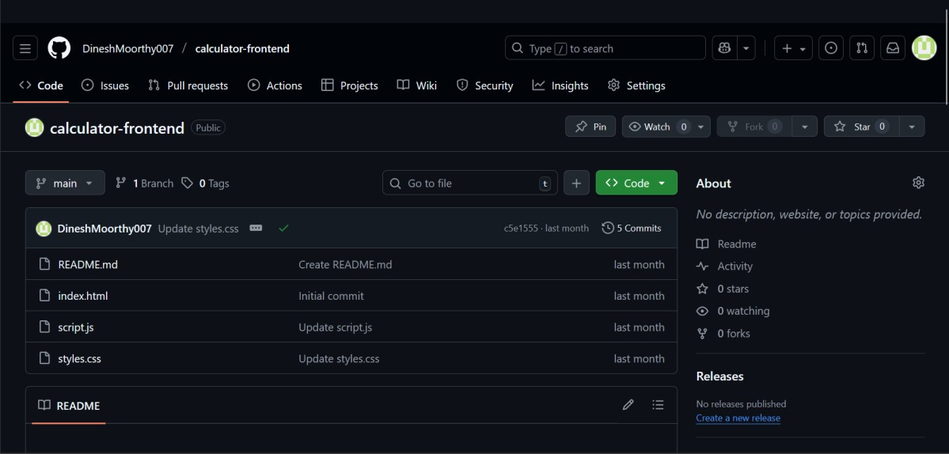

Description :
The frontend of the Distributed Calculator provides a clean and interactive web interface built using HTML, CSS, and JavaScript. The interface communicates with the backend via RESTful APIs, ensuring smooth data transfer and real-time responses.
Backend Structure :

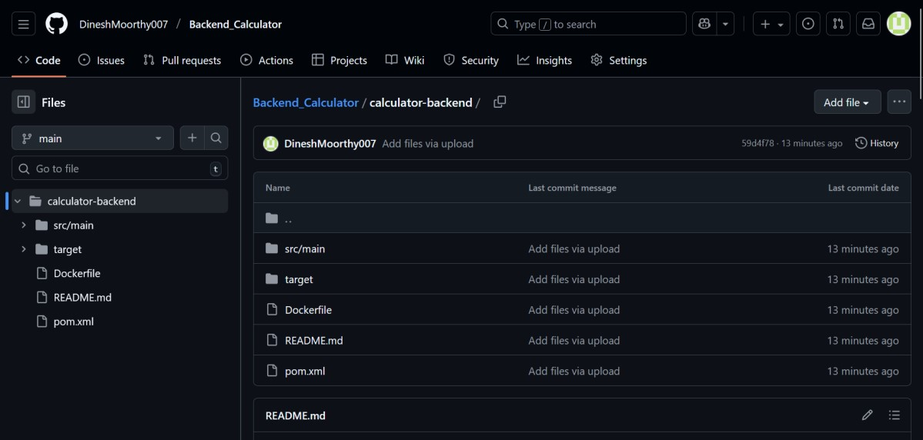

Description :
The backend of the Distributed Calculator is developed using Java Spring Boot with integrated RMI (Remote Method Invocation) support. The server processes client requests, performs arithmetic operations, returns results in real time and deployed using Docker and Render.

Docker Image for Backend :

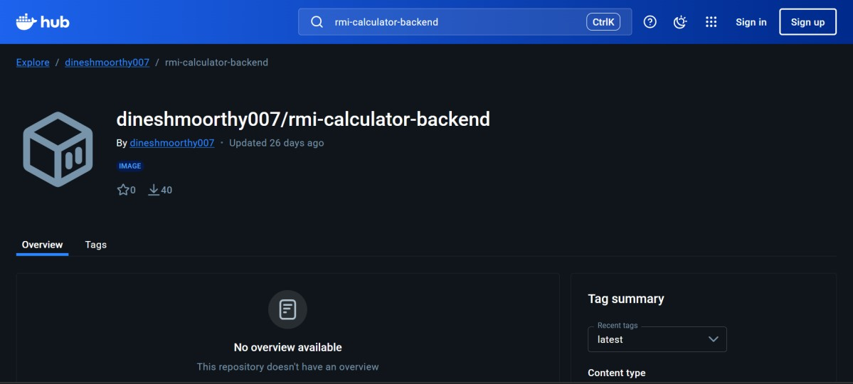
Description :
The Docker image packages the entire backend application along with its dependencies into a portable container. Using Docker simplifies deployment, making the backend easily runnable on any system or cloud platform.

Render Deployment :

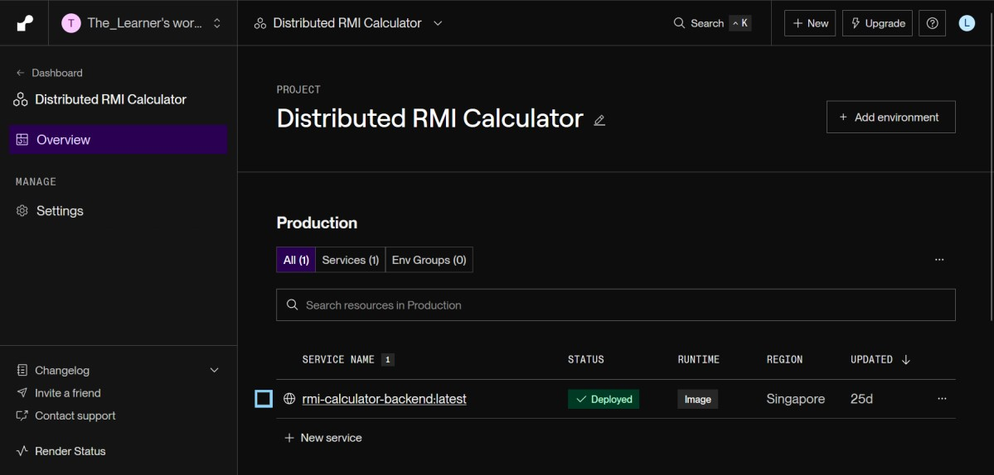

Description :
The Docker image of the backend is deployed on Render, a cloud platform that automates container hosting. Render pulls the Docker image from the repository and runs it as a live backend service accessible via the web. This allows users to access the distributed calculator’s backend globally with minimal configuration.

Github Pages :

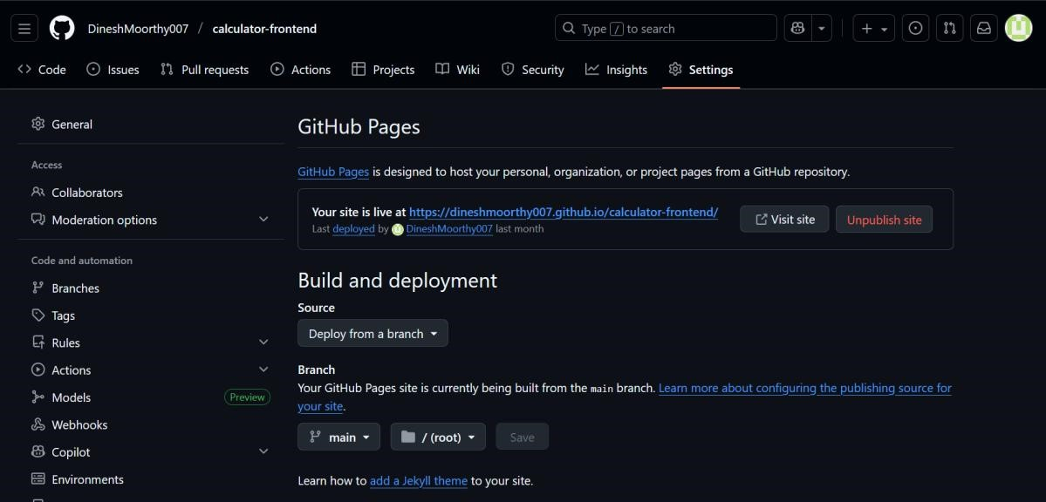

Description :
The frontend of the calculator application is hosted on GitHub Pages for easy and free web access.It serves the HTML, CSS, and JavaScript files directly from the GitHub repository.The website connects to the backend API hosted on Render for real-time calculations.This setup provides a lightweight, accessible, and globally available interface for users.

Website Output Pages :
The website displays a clean and interactive home page with input fields and operation buttons for performing calculations. It correctly shows results for valid inputs, ensuring smooth interaction with the backend API. When a division by zero occurs, the system displays a clear “Cannot divide by zero” error message. For invalid or empty inputs, the website provides instant feedback, prompting users to enter valid numbers before proceeding.

Conclusion :
The distributed calculator project successfully demonstrates how backend computation and frontend interaction can be integrated using Java RMI, Spring Boot, and HTML/CSS/JavaScript. It ensures real-time processing of arithmetic operations while maintaining data integrity and user accessibility across platforms. Hosting the backend using Docker and Render, and the frontend through GitHub Pages, showcases the adaptability and scalability of the system. Overall, the project emphasizes modular design, cloud deployment, and efficient user experience.

Future Work :

- Extend the calculator to support advanced mathematical operations (e.g., trigonometric and logarithmic functions).
- Implement user authentication for personalized usage history.
- Enhance UI/UX with modern frameworks like React or Angular.
- Integrate database support for storing and retrieving previous calculations.
- Deploy using CI/CD pipelines for automated testing and continuous updates.
- Add multi-language support and voice-enabled interactions for accessibility.

